**Lesson 9 Demo 1**

**How to Install Nagios Monitoring Tool**



Steps to be followed:

1. Installing package dependencies
2. Installing Nagios Core 4.4.6
3. Installing Nagios and NRPE plugins

**Step 1: Installing package dependencies**

1. Install the package dependencies using the following commands:

***sudo apt update***

***sudo apt install -y autoconf bc gawk dc build-essential gcc libc6 make wget unzip apache2 php libapache2-mod-php libgd-dev libmcrypt-dev make libssl-dev snmp libnet-snmp-perl gettext***



**Step 2: Installing Nagios Core 4.4.6**

1. Download the Nagios Core source code

***cd ~/***

***wget*** [***https://github.com/NagiosEnterprises/nagioscore/archive/nagios-4.4.6.tar.gz***](https://github.com/NagiosEnterprises/nagioscore/archive/nagios-4.4.6.tar.gz)

***tar -xf nagios-4.4.6.tar.gz***

***cd nagioscore-*/***

1. Create the Nagios user and group using the below commands

***sudo useradd nagios***

***sudo groupadd nagcmd***

***sudo usermod -a -G nagcmd nagios***

### Compile and install Nagios

### ***sudo ./configure --with-httpd-conf=/etc/apache2/sites-enabled***

### ***sudo make all***

1. Run the following commands to install Nagios binaries, service daemon script, and the command mode.

### ***sudo make install***

### ***sudo make install-daemoninit***

### ***sudo make install-commandmode***

### ***sudo make install-config***

1. Install the Apache configuration for Nagios and activate the *mod_rewrite*and *mode_cgi*modules and restart the apache service

### ***sudo make install-webconf***

### ***sudo a2enmod rewrite cgi***

### ***sudo service apache2 restart***

1. As you have installed the Nagios Core 4.4.6. Now create nagiosadmin user

### ***sudo htpasswd -c /usr/local/nagios/etc/htpasswd.users nagiosadmin***

1. Enter the password of your choice. You need to remember it as this will be used to login to nagios later
2. For the firewall configuration, run the command below

### ***for svc in Apache ssh***

### ***do***

### ***sudo ufw allow $svc***

### ***done***

1. To start the UFW firewall service and add it to the system boot, run

### ***sudo ufw enable***

**Step 3: Installing Nagios and NRPE plugins**

1. Run the following command:

***sudo apt install monitoring-plugins nagios-nrpe-plugin***

1. Now, go to the nagios installation directory */usr/local/nagios/etc* and create a new directory for storing all server hosts configuration

### ***cd /usr/local/nagios/etc***

### ***sudo mkdir -p /usr/local/nagios/etc/servers***

1. Edit the Nagios configuration *nagios.cfg* using the vim editor

### ***sudo vim nagios.cfg***

1. Press ***i*** anduncomment the cfg_dir option that will be used for storing all server hosts configurations

### ***cfg_dir=/usr/local/nagios/etc/servers***

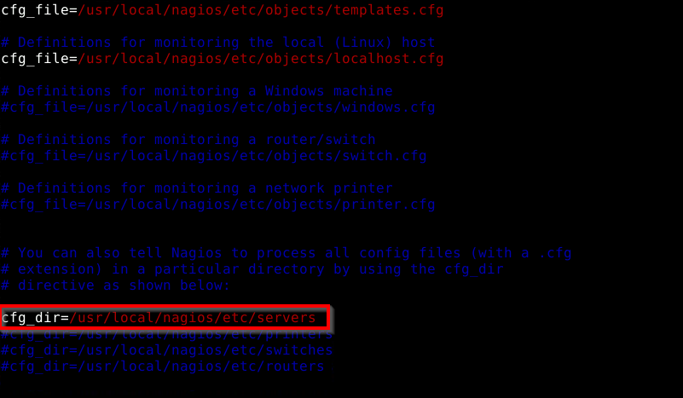

1. Save and close. Now edit the configuration file *resource.cfg*

### ***sudo vim resource.cfg***

1. Define the Nagios Monitoring Plugins path by changing the default configuration as shown below

### ***$USER1$=/usr/lib/nagios/plugins***

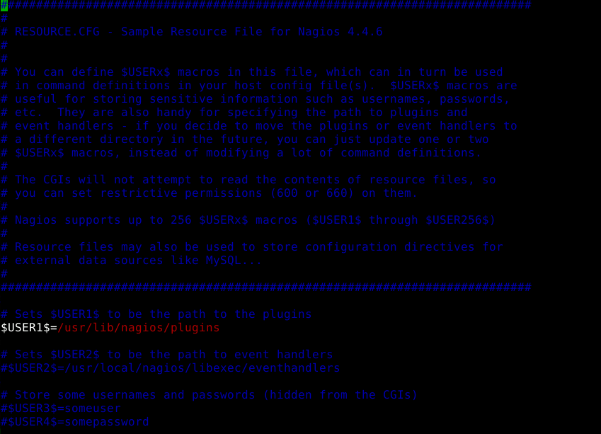

1. Save and close the file. Now edit the *objects/contacts.cfg* file and add the nagios admin email contacts

### ***sudo vim objects/contacts.cfg***

1. Change the email address with your own

### ***define contact{***

### ***......***

### ***email <YourEmailId>***

### ***}***

1. Save and close. Edit the *objects/commands.cfg* file

### ***sudo vim objects/commands.cfg***

1. Add the following configuration to the end of the file

### ***define command{***

### ***command_name check_nrpe***

### ***command_line $USER1$/check_nrpe -H $HOSTADDRESS$ -c $ARG1$***

### ***}***

1. Save and close, and the Nagios core configuration has been completed. Run the following commands:

### ***sudo systemctl start nagios***

### ***sudo systemctl enable nagios***

1. The Nagios service should be up and running, check using the following command:

### ***sudo systemctl status nagios***

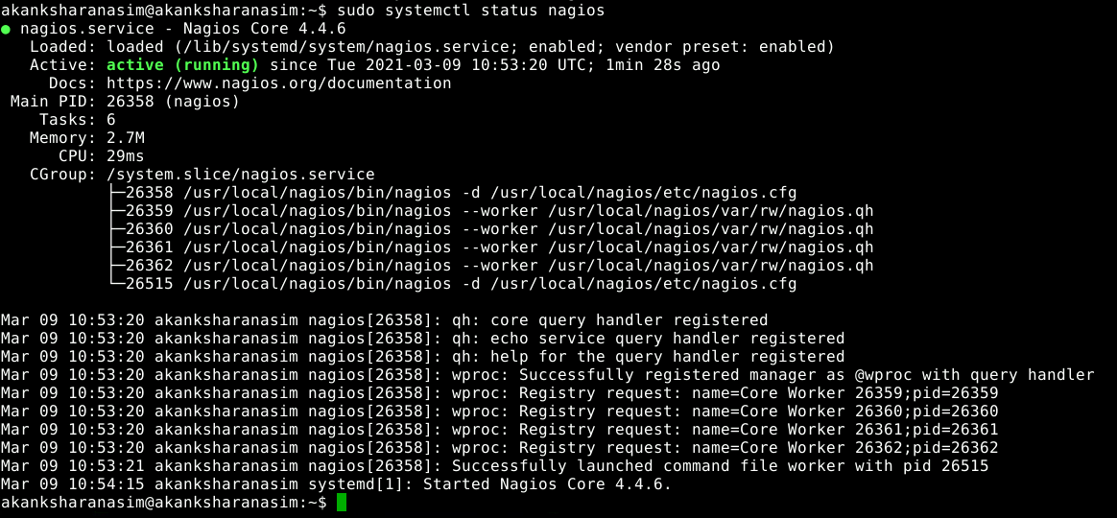

1. Restart the Apache service to apply a new Nagios configuration

### ***sudo systemctl restart apache2***

1. Now open your web browser and type the server IP address following the nagios URL

### ***http://localhost/nagios/***

1. Now you will have to log in with the user ***nagiosadmin*** and type your *password*

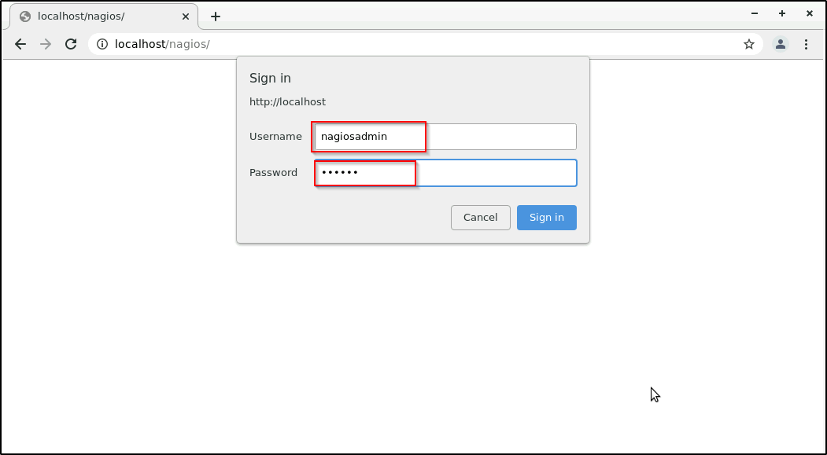

1. You will get the Nagios Dashboard as shown below:

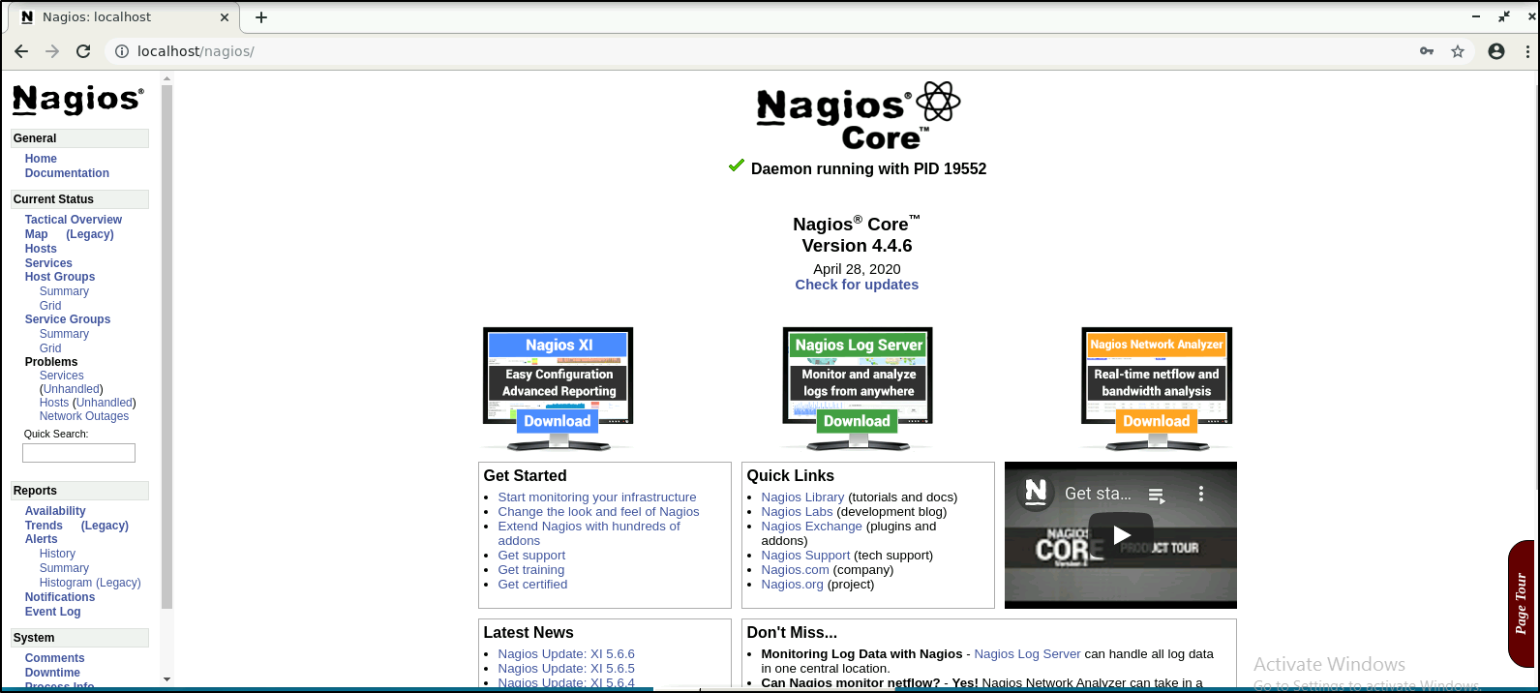

1. You've installed Nagios on the Ubuntu server.

